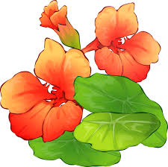

Taking Photos of Your Garden
Over the winter, your photographs will enable Judy to provide guidance about your individual situation. TREE photos are especially important. Take three separate pictures: the bark, the leaves and leaves on the branches. Take a long-shot of the whole garden. Photograph existing flower beds and where you may want to establish a bed. Take notes on what you like and don’t like.

Taking Soil Samples
Select various sections of the garden, perhaps four.
- Dig down six inches. Take one cup of soil from that depth.
- Put each sample in a Ziploc bag marked with your name and the garden location for each.
- Keeping each sample separate, empty the soil onto a tray (like a large cookie sheet) to dry.
- When completely dry, return the samples to the correct bag.
NOTE: It could take a week or more for the soil to be absolutely dry, so don’t delay on doing this.

